**COMSATS University Islamabad**

 **Sahiwal Campus**

**Assignment 02(class)**

**Submitted to:**

Proff. Abuzar Baqir

CUI, Sahiwal

**Submitted by:**

Mah Noor

FA23-BCS-332

COAL

**Department of Computer Science**

**QUESTION NO.01**

**A)**

**MUL BX,IF AX=0008H AND BX=0003H**

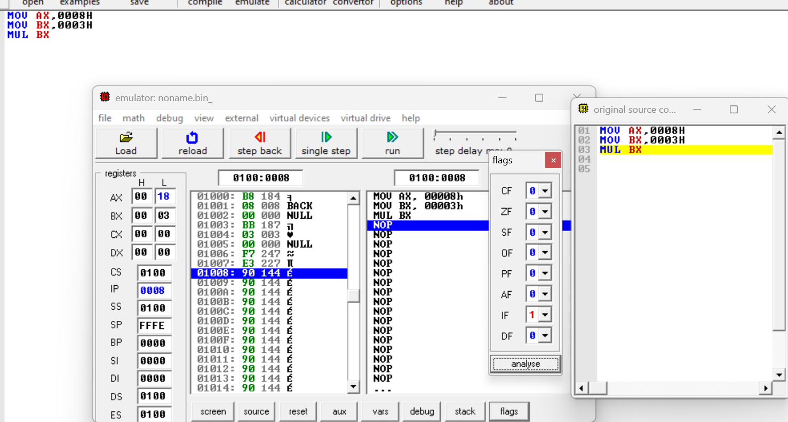

MUL BX=dx:ax=0008h*0003h=24(decimal) =0018h

**Result:**

DX=0000H

AX=0018H

CF/OF=0

**EXPLANATION:**

* MUL BX multiples ax by bx storing the result in dx:ax
* The result is 00018h which fits within 1 register(result doesn’t exceed 16 bits)
* Since dx remains 0000h , no overflow occurred both cf and of are thus cleared

**B)**

**MUL BX,IF AX=00FFH AND BX=1000H**

MUL BX=dx:ax=00ffh*1000h =00ff000h

**Result:**

DX=000fH

AX=F000H

CF/OF=1

**EXPLANATION:**

* The multiplication produced a 24 bit result , but dx:ax stores 32 bit
* The lower go to ax, the higher bits go into dx
* Since dx is nonzero cf and of are changed to 1.

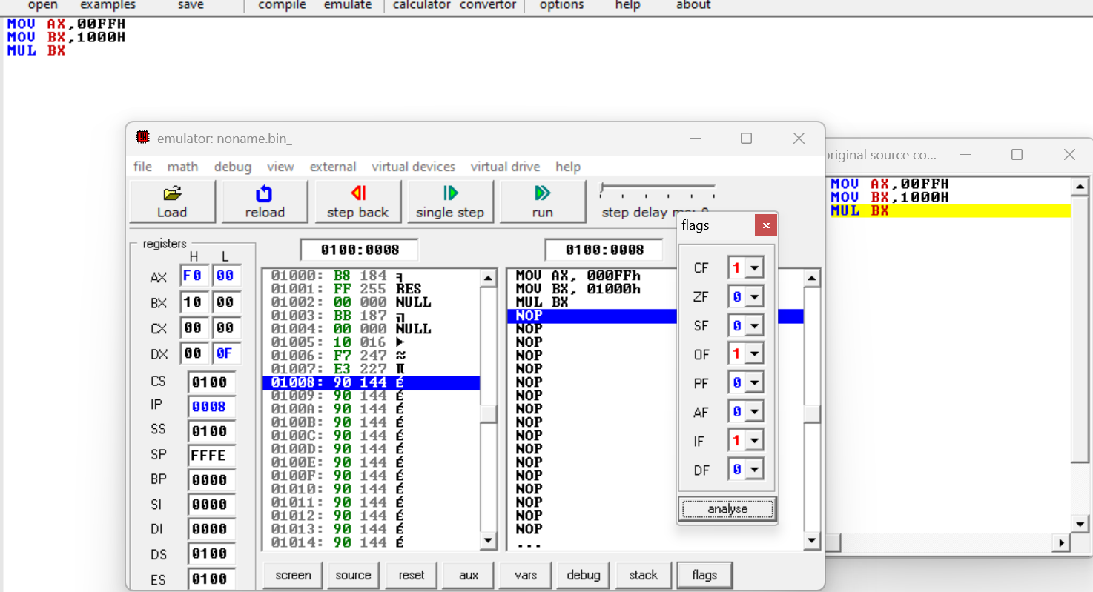

**QUESTION NO.02**

**A)**

**MUL Bl,IF Al=0ABH AND BL=10H**

This is unsigned multiplication . al=abh=171(decimal)

Bl=10h=16(decimal)

Mul bl=171*16=2736=0AB0h

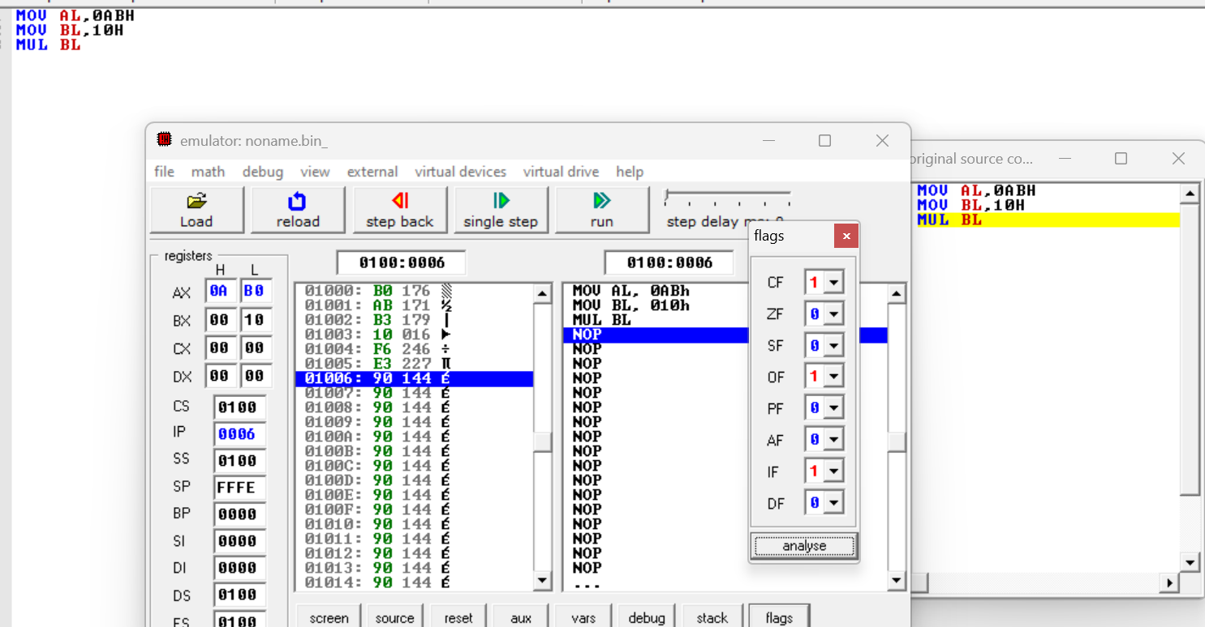

**Result:**

AX=0AB0H

CF/OF=1

**EXPLANATION:**

* In mul,both carry flag and overflow flag are set if upper byte is non-zero.
* Here ax=0AB0h , ah=0Ah , ah isn’t 0 so cf and of are 1

**B)**

**IMUL Bl,IF Al=ABH AND BL=10H**

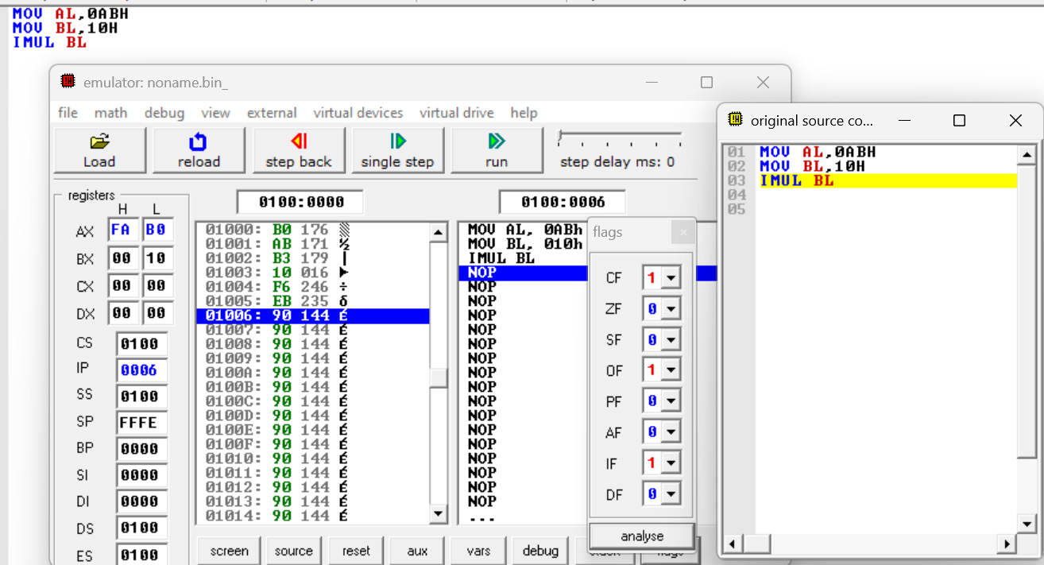

**Result:**

AX=FAB0H

CF/OF=0

**EXPLANATION:**

* Since IMUL in 8 bit mode expects the result to fit in al but the multiplication produces a 16 bit result , overflow occurs setting cf and of to 1.

**QUESTION NO.03**

**A)**

**Div BX, DX=0000H , AX=0007H AND BX=0002H**

* Divident =dx:ax = 0000h:0007h=7
* Divisor=bx=0002h=2
* Quotietnt=ax=0003h
* Remainder=dx=0001h

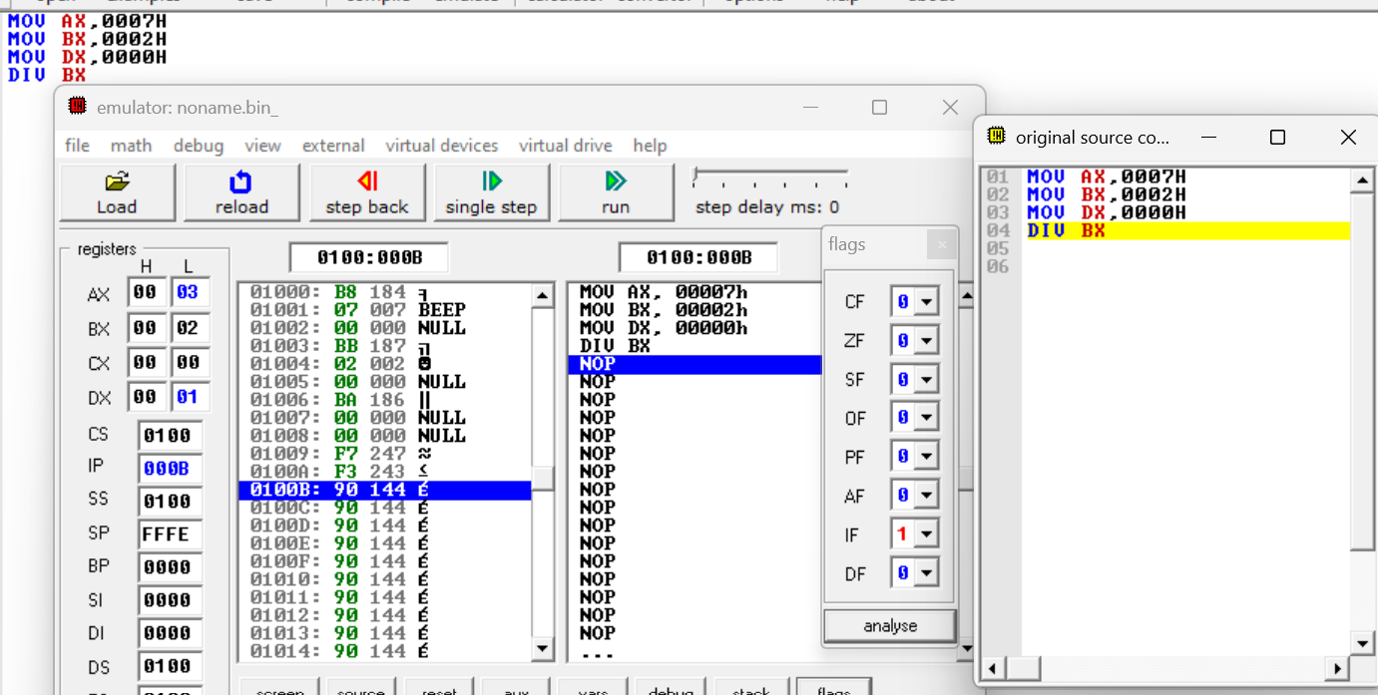

**B)**

**Div BX, DX=0000H , AX=FFFEH AND BX=0010H**

* Divident =dx:ax = 0000h:FFFEh=65534(decimal)
* Divisor=bx=0010h=16(decimal)
* Quotietnt=ax=0FFFh
* Remainder=dx=000Fh

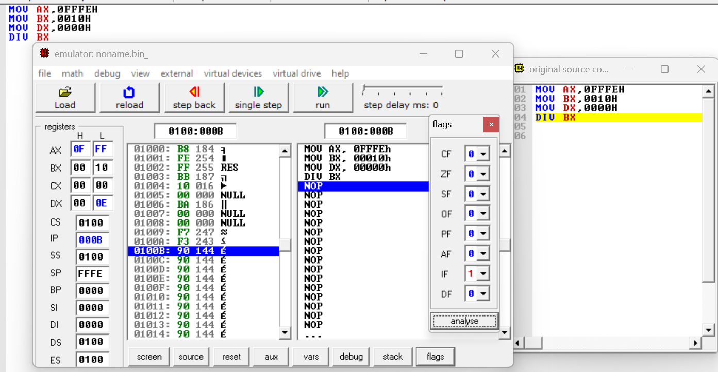

**QUESTION NO.04**

**A)**

**Div Bl, AX=000DH and BL=03h**

* Divident =dx:ax = 0000h:000Dh=13
* Divisor=bx=03h=3
* Quotietnt=Al=0004h
* Remainder=Ah=01h

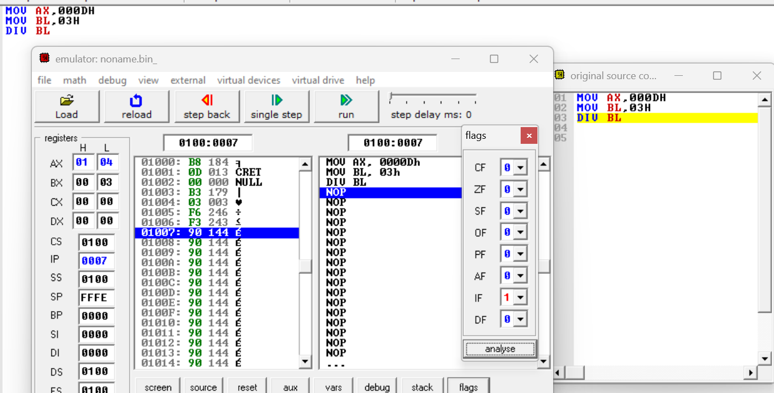

**B)**

**IDiv Bl, AX=FFFBH and BL=FEh**

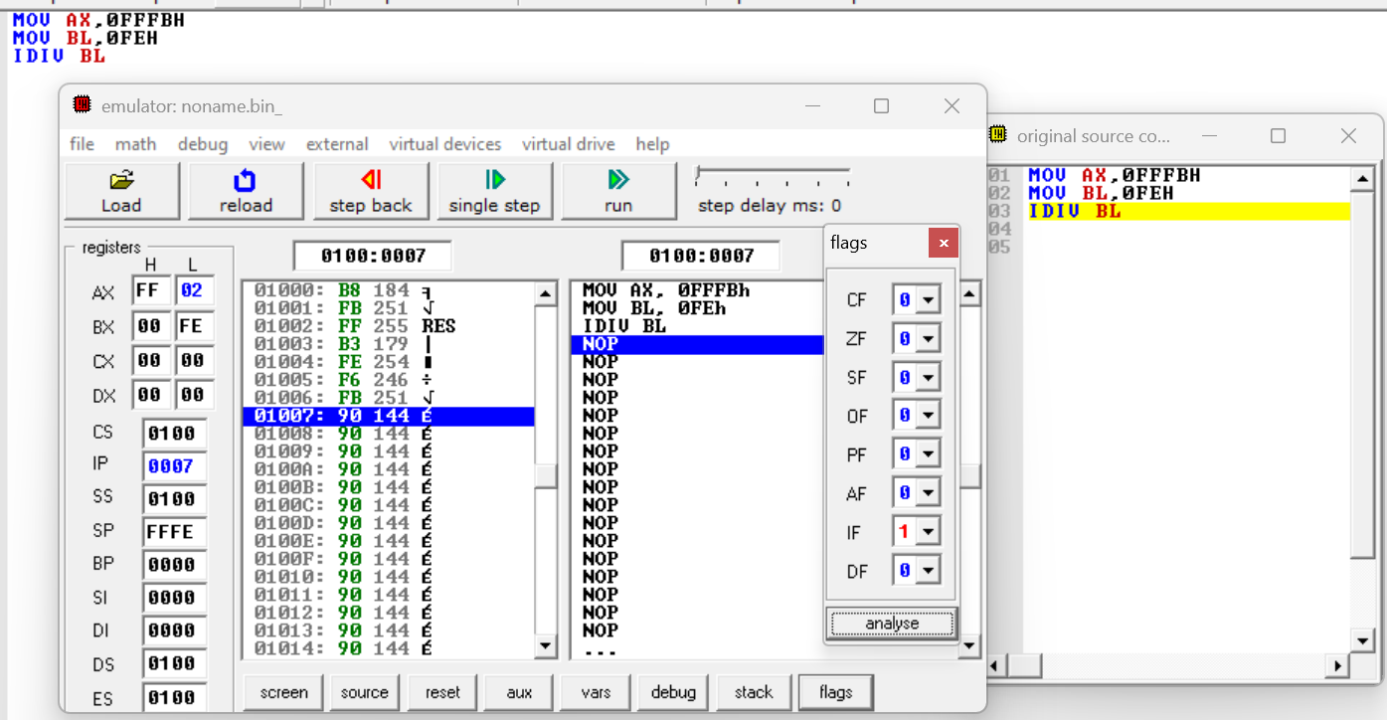

Quotietnt=Al=02h

Remainder=Ah=FF

**QUESTION NO.05**

**CWD**

* Convert word to double word,
* If ax is positive(msb=0), dx is set to 0000h
* If ax is negative(msb=1),dx is set to FFFFh

**A)**

**AX=7E02h**

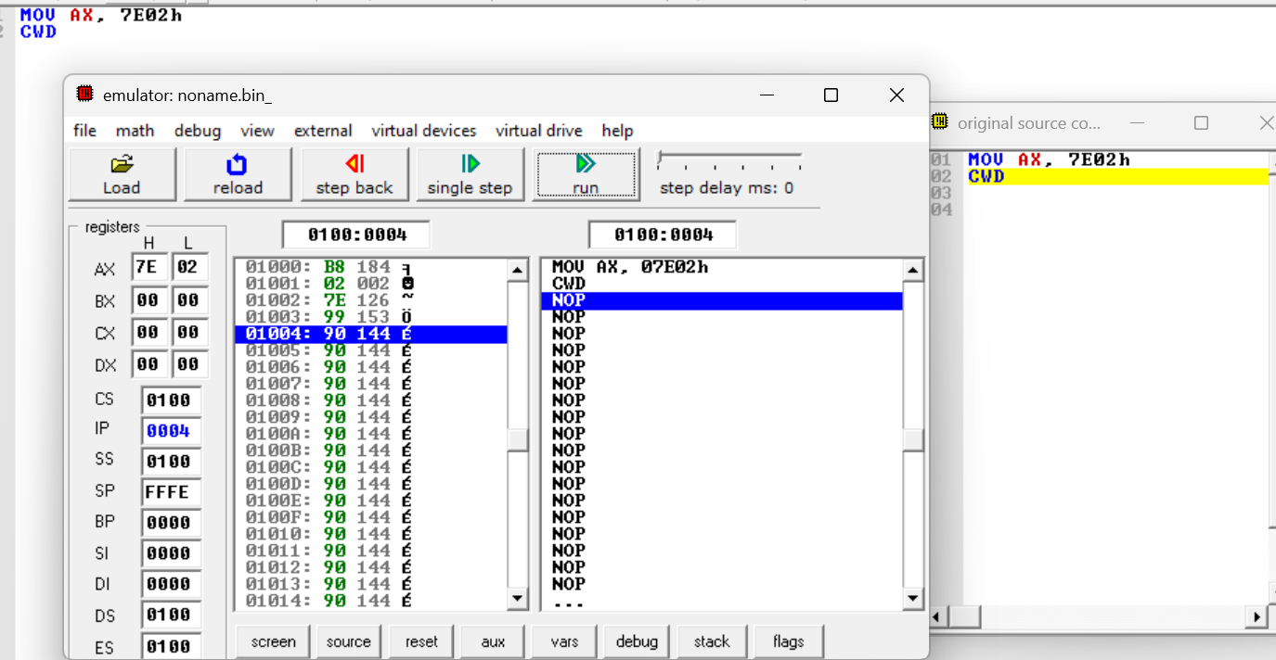

**A)**

**AX=8ABCh**

